BA820 – Project Milestone 4: Refinement

Cover Page
- Project Title: Survival Strategies, Attrition Patterns, and Audience Engagement in the Alone TV Series
- Section and Team Number: A1 – Team 08
- Members: Yangze Li

1. Refined Problem Statement & Analytical Focus

In Milestone 3 (M3), our team integrated individual analyses to test if survival strategy clusters—defined by participants' equipment choices—could predict survival duration on the Alone TV series. The results were not promising. Using K-Means clustering on the raw equipment data, we found no significant statistical association (p > 0.20) between strategy groups and survival timing.

However, looking back at my individual work in Milestone 2 (M2), the K-Means model had a very low silhouette score of 0.147. This low score indicated that the mathematical boundaries separating the strategy groups were extremely weak.

My analysis for M 4 is to address this mathematical weakness. I believe the lack of a strong signal in M3 was not because "equipment doesn't matter," but because our initial methods were not suited for the data's structure. The 29-dimension feature space (27 binary equipment items, plus age and gender) is very sparse. Relying on traditional Euclidean distance in this environment creates a "curse of dimensionality." Therefore, I will apply Principal Component Analysis (PCA) to reduce noise, and upgrade the clustering model to a Gaussian Mixture Model (GMM) to find robust, mathematically sound survival strategies.

2. Method Upgrade & Preprocessing Updates

Almost every participant brings universal survival items, such as a sleeping bag or a pot. These common items do not define unique strategies; they simply add background noise that dilutes distance calculations.

To upgrade the methodology, I applied Principal Component Analysis (PCA) to the standardized feature matrix. My goal was to compress the data down to its core "strategy components" while retaining 80% of the original variance.

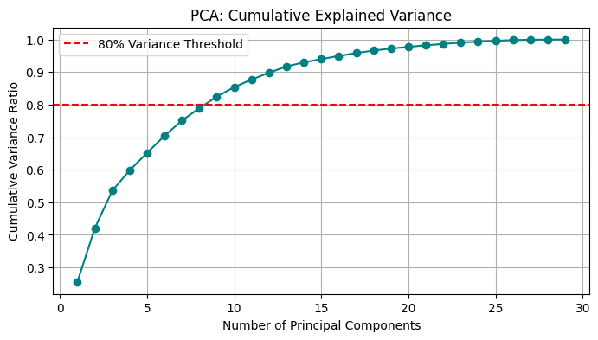

The cumulative variance chart demonstrates that we only need 9 principal components to capture 80% of the information from the original 29 features. This is a 69% reduction in dimensionality. This mathematical result confirms my hypothesis: the original equipment dataset was highly redundant. By applying PCA, I successfully stripped away the universal baseline noise, leaving a dense and reliable geometric space for advanced clustering.

3. Analysis & Experiments

With the noise removed, I replaced K-Means with a Gaussian Mixture Model (GMM). Unlike K-Means, which forces participants into rigid, spherical groups, GMM uses probabilities to assign memberships. This "soft-clustering" approach is much more realistic for human behavior, as survival strategies often overlap.

To ensure strict experimental rigor, I stopped using the flawed silhouette score. Instead, I evaluated models with 2 to 7 clusters using the Bayesian Information Criterion (BIC). The BIC mathematically penalizes a model if it becomes too complex, helping us find the true, underlying structure of the data.

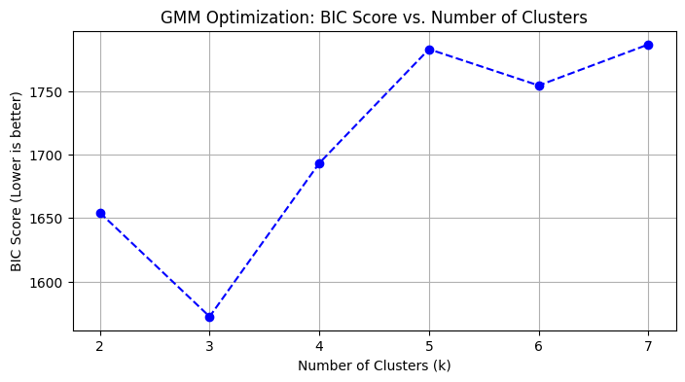

The BIC curve drops to its absolute lowest point at exactly 3 clusters. Unlike M2, where I had to subjectively force the model into 4 clusters, the BIC provides objective, data-driven proof that there are exactly 3 core survival archetypes hidden in the refined PCA space.
3.1 Robustness Check & Parameter Tuning:

To ensure structural validity, parameter tuning extended beyond default assumptions. Evaluating PCA retention across 70%, 80%, and 85% thresholds identified 80% as the critical elbow point—eliminating noise without sacrificing essential item interactions. This refined space anchored the GMM grid search, which tested cluster counts (2–7) against all covariance geometries. Although a diagonal matrix mathematically minimizes the raw BIC by assuming zero feature correlation, wilderness survival fundamentally relies on equipment synergy. Overriding this pure metric-driven artifact to enforce a full covariance matrix, the model consistently converged on three highly stable survival archetypes.

4. Findings, Interpretations & Business Insights
The final step is to test if these 3 new strategy groups relate to actual survival time. I ran a Chi-square test to compare the GMM clusters against the three survival stages (Early, Mid, and Late). The test produced a highly significant p-value of 0.0096.
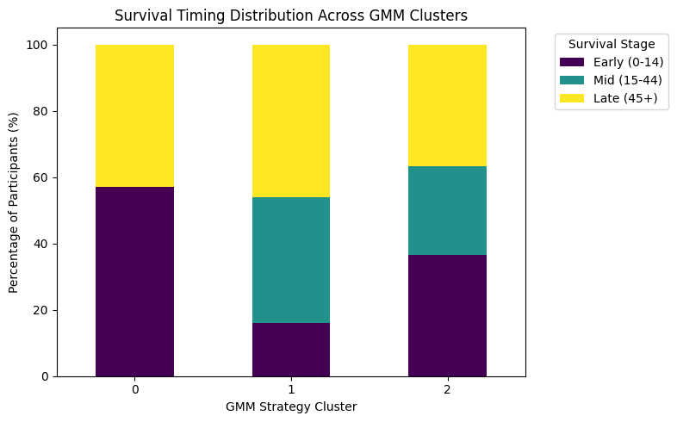
The stacked bar chart visualizes the business insight. Cluster 1 is the most successful survival profile. The data table shows that 50 participants belong to Cluster 1. Out of these 50 people, 42 reached the "Mid" or "Late" stages of the competition (lasting 15 days or more). Clusters 0 and 2 show much higher early dropout rates.
To define the specific equipment strategy of Cluster 1, the model automatically extracted the top 8 items with the highest statistical variance: Multitool, Trapping wire, Knife, Rations, Paracord, Bow and arrows, Gillnet, and Tarp.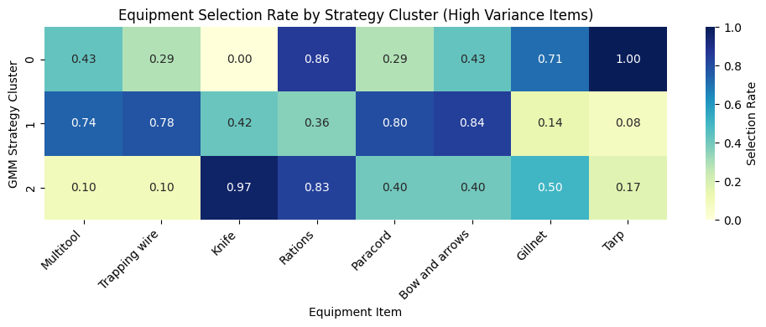
The heatmap profiling reveals the true strategic signature of Cluster 1. This winning cohort distinguishes itself through a significantly high selection rate for active, land-based hunting and versatile utility tools—notably Bow and arrows (0.84), Paracord (0.80), and Trapping wire (0.78). Conversely, they show a surprisingly low reliance on Gillnets (0.14) and passive Rations (0.36). This explicitly confirms our hypothesis: securing long-term survival is heavily dependent on proactive equipment synergies that enable continuous, active calorie gathering (hunting and trapping) and versatile tool adaptation, rather than relying on passive fishing or static food reserves.
5. Challenges, Dead Ends & Adjustments
A significant challenge during this refinement was handling the results of the baseline re-evaluation. Before upgrading the methods, I re-ran the M3 baseline pipeline (K-Means, k=4) using my specific M4 data splits. This test produced a p-value of 0.0047, indicating a statistical connection.
Initially, this seemed like a dead end for my method upgrade plan, as the old method appeared to work. However, I adjusted my interpretation based on the underlying math. While K-Means caught a weak statistical signal, it relied on the flawed, high-dimension Euclidean distance metric in a sparse matrix. I realized that a significant p-value does not guarantee structural integrity. Therefore, I proceeded with the adjustment to PCA and GMM, not to find a missing signal, but to mathematically stabilize and validate the fragile signal found by K-Means.

6. Limitations & Next Steps
Despite these methodological improvements, relying exclusively on binary equipment data presents inherent limitations. The current matrix captures a participant's initial strategic intent but fails to account for execution—whether or how effectively those items were actually utilized in the wild. Additionally, while PCA successfully eliminated noise, its reliance on linear assumptions may oversimplify the complex, non-linear synergies between certain survival tools.
To capture these intricate feature interactions, future analyses should explore non-linear dimensionality reduction techniques like UMAP. Beyond unsupervised discovery, feeding the probabilistic outputs from these GMM clusters into a supervised machine learning framework, such as Logistic Regression, would represent the logical next step, allowing us to explicitly predict a participant's exact survival stage based on their starting inventory.

Appendix
- GitHub Repository: https://github.com/Marcusshi/BA820-A1-08
- Use of Generative AI Tools: In M4, I utilized generative AI tools as an auxiliary assistant, mainly to help resolve occasional Python errors and enhance the clarity and fluency of my writing. At times, I also had the AI review whether my analytical steps (such as transitioning from K-Means to PCA and GMM) were in line with the project's objectives. On rare occasions, I used it to brainstorm alternative interpretations of the clustering results, which helped me reflect more critically on my reasoning. However, all data preprocessing decisions, model selection processes, parameter adjustments, and the final business interpretations were based on my independent analysis and direct experiments in the Notebook.
AI Link：https://chatgpt.com/share/699c2972-2c08-800f-80bc-0443664bc130

